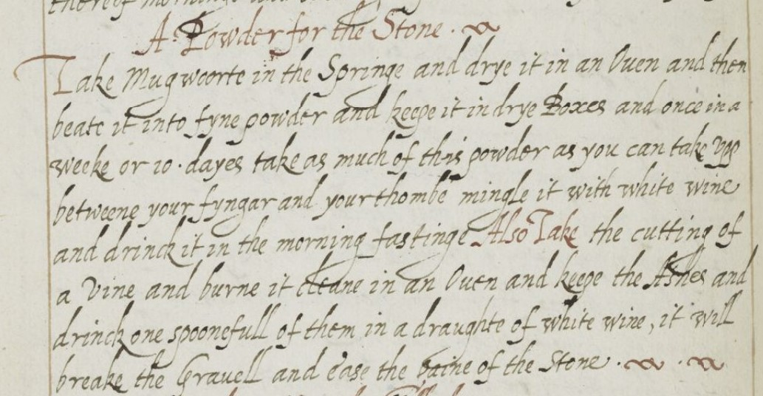

A Powder for the Stone. flourish

Take mugwoorte in the Springe and drye it in an Oven and then

beate it into fyne poweder and keepe it in drye Boxes and once in a

weeke or 10 dayes take as much of this powder as you can vpp

betweene your fyngar and your thombe mingle it with white wine

and drinck it in the morning fastinge Also Take the cutting of

a vine and burne it in an Oven and keepe the ashes and

drinck one spoonefull of them in a draughte of white wine, it will

break the Grauell and ease the paine of the stone. flourish flourish

Definitions:

Stone: in this context, a kidney stone (National Library of Medicine)

Mugwoorte: mugwort, a perennial flowering plant native to the Old World (National Center for Complementary and Integrative Health)

Grauell: gravel, here refers to small kidney stones (wiktionary.org)

Purpose of the Recipe:

This recipe is intended to help break down kidney stones and relieve pain from said ailment.

Ingredients:

Mugwort

White wine

Ashes from a vine

Process:

Dry out some mugwort, powderize it, and store it in a dry container for between a week and ten days. Then, before eating breakfast, take as much as one can pinch between one’s finger and thumb and mix with a glass of white wine before consuming. Also take a vine cutting, burn it in the oven, and take a spoonful of the ashes with some white wine.

Observations:

My biggest annoyance was the lack of punctuation, as I had to keep resisting the urge to put commas and periods where instinct told me to put them. I also was not sure whether to render the “g” in “Grauell” as capital or lowercase, as it had qualities of both, and the book said nothing about it. In the end, I chose to render it as a capital, as the other lowercase g’s did not have the arch on top. I know next to nothing about medicinal practice, and doing some brief research has yielded mixed results, so I personally would be skeptical of this remedy. I would guess that will be common to most of these.

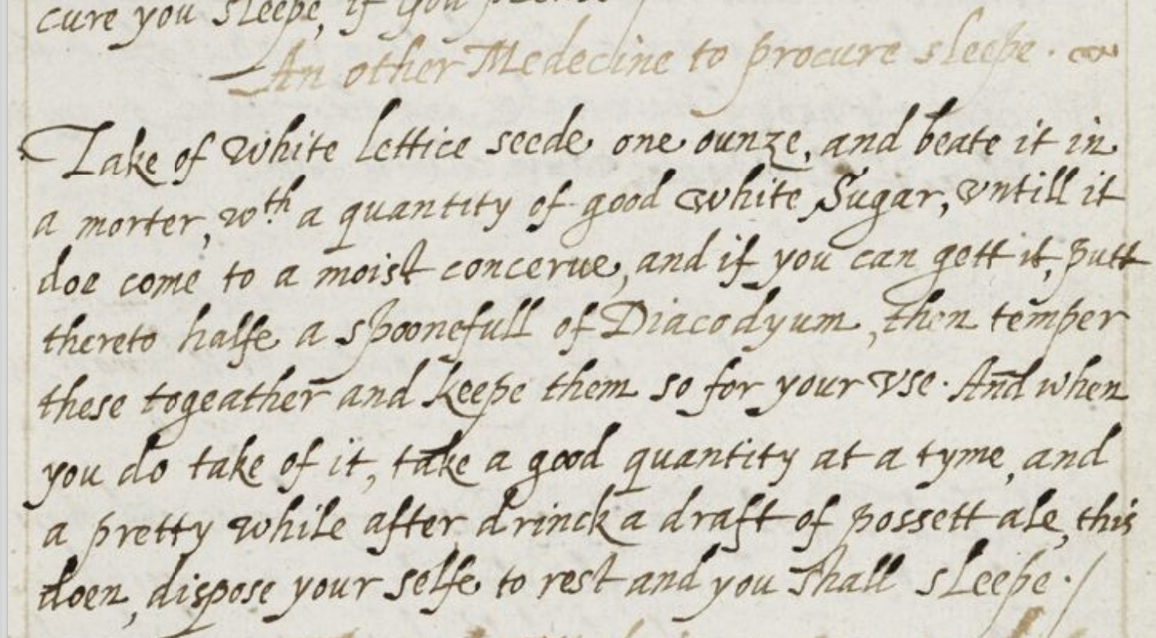

An other medecine to procure sleepe. flourish

Take of white lettice seede, one ounze, and beate it in

a mortar, w*i*th a quantity of good white Sugar, untill it

doe come to a moist concerue, and if you can get it, putt

thereto halfe a spoonefull of Diacodyum, then temper

these togeather and keepe them so for your vse. And when

you do take of it, take a good quantity at a tyme, and

a pretty while after drinck a draft of possett ale, this

doen, dispose your selfe to rest and you shall sleepe.

Definitions

Concerue: a substance made from a plant part mixed with sugar, usually for either culinary or medicinal purposes. In simpler words, a jelly, jam, or preservative. (Newcastle University)

Diacodyum: a syrup made from poppies used as a sleeping medicine (Merriam-Webster).

Possett: a warm, alcoholic drink made by mixing milk, ale, and some spices together (Oxford Dictionary).

Purpose of the Recipe:

The purpose is to help an insomniac sleep.

Ingredients:

White lettuce seeds

Sugar

Diacodium

Posset ale

Process:

Crush together an ounce of white lettuce seeds with some sugar until it becomes a jelly, and add diacodium if possible. When you need to use it, eat a sizeable amount, and drink some posset after waiting a bit. Then go rest.

Observations:

I appreciate the use of punctuation for this one, although the run-on sentences (which I have heard are common to this time period) still throw me a bit. Looking up the definition for diacodium was also slightly difficult because of the alternate spelling. Common sense now tells me I should have considered changing the y to an i sooner. As for the medicine itself, I am not sure what the lettuce seeds would do. But I can say with reasonable confidence that a sleeping medicine with milk and alcohol would put most people to sleep.

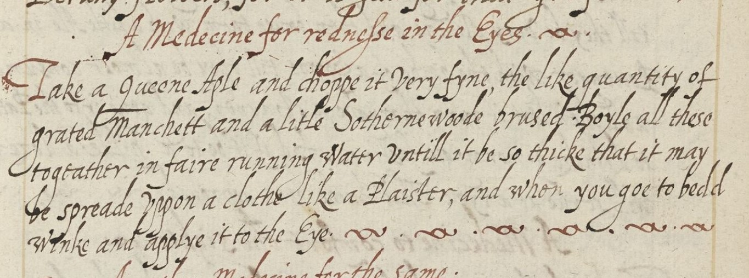

A medecine for redneſse in the Eyes. flourish

Take a queene Aple and choppe it very fyne, the like quantity of

grated manchett and a little Sothernewoode brused. Boyle all these

togeather in faire running water untill it be so thicke that it may

be spreade upon a clothe like a Plaister, and whon you goe to bed

winke and applye it to the Eye. flourish. flourish. flourish. flourish. flourish. flourish

Definitions:

Manchett: high-quality wheat bread (Merriam-Webster)

Sothernewoode: a fragrant European wormwood with a bitter taste (Merriam-Webster)

Plaister: a paste made of lime, sand, and water that is applied to walls and ceilings to dry (Collins Dictionary)

Purpose of the Recipe:

This recipe helps deal with red eyes.

Ingredients:

A Queen apple

Wheat bread

Crushed southernwood

Process:

Chop the apple very finely, mix it with an equal part of the wheat bread and a little bit of the southernwood, and boil it all together until it becomes a thick paste. Spread it on a cloth, close the affected eye, and go to sleep with the cloth on it.

Observations:

The only difficult word this time around was Sothernewoode, again because I did not think to update the spelling to modern English. This one was on the shorter side, so I did not find many other issues as I was transcribing it. As for the recipe itself, I find myself questioning the specifics. Why a Queen apple specifically? Why Manchette specifically? Do they have anti-bacterial properties that make them high-quality in the first place? And what is meant by boiling the mixture in running water? Do they just mean that the water is bubbling as if it were running?

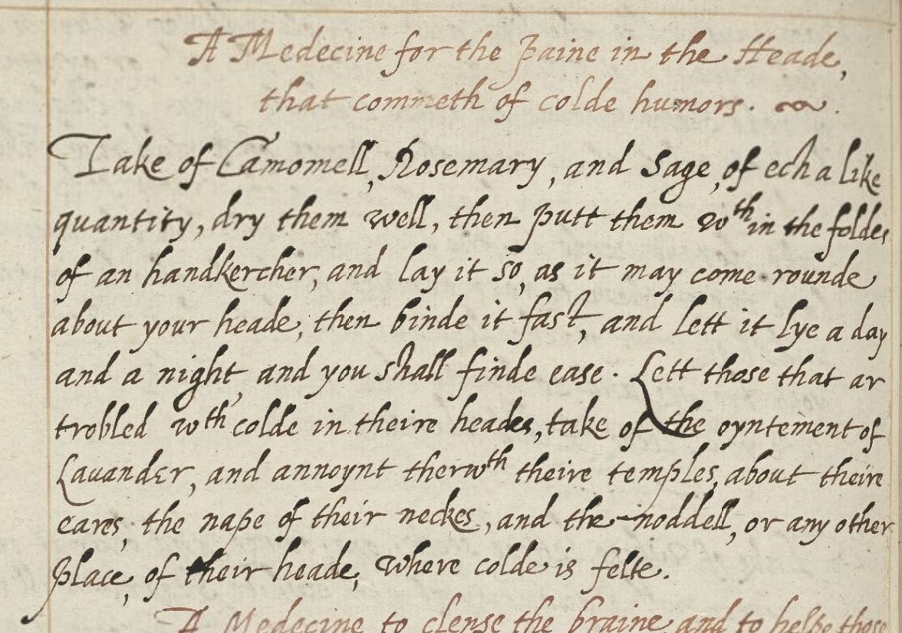

A Medecine for the paine in the Heade,

That commeth of colde humors. flourish.

Take of Camomell, rosemary, and sage, of ech a like

quantity, dry them well, then putt them w*i*thin the folder

of an handkercher, and lay it so, as it may come rounde

about your heade, then binde it fast, and lett it lye a day

and a night, and you shall finde ease. Lett those that ar

trobled w*i*th colde in theire heads, take of the oyntement of

lauander, and annoynt therew*i*th their temples, about theire

caves, the nape of their neckes, and the noddell, or any other

place of theire heade, where colde is felte.

Definitions:

Caves: near as I can tell, some sort of cavity on the human head, probably nostrils.

Noddell: The back of the head (National Library of Medicine)

Purpose of the Recipe:

This recipe is for dealing with headaches that come from colds.

Ingredients:

Chamomile

Rosemary

Sage

Lavender

Process:

Take the first three herbs in equal quantities, dry them, fold them together in a handkerchief, and tie it around one’s head securely. Leave it for 24 hours and there should be relief. Lavender, applied wherever the effects of the cold are felt, will also work.

Observations:

This one was comparatively easy. The only things of note to me on the linguistic side were discovering yet another variation on the word handkerchief, and the two new anatomy words. It did take me a while to figure out Chamomile, I will admit. On the medicinal side, this one is more credible to me. I can certainly attest to my mother using lavender oil on me for headaches and it bringing some relief.

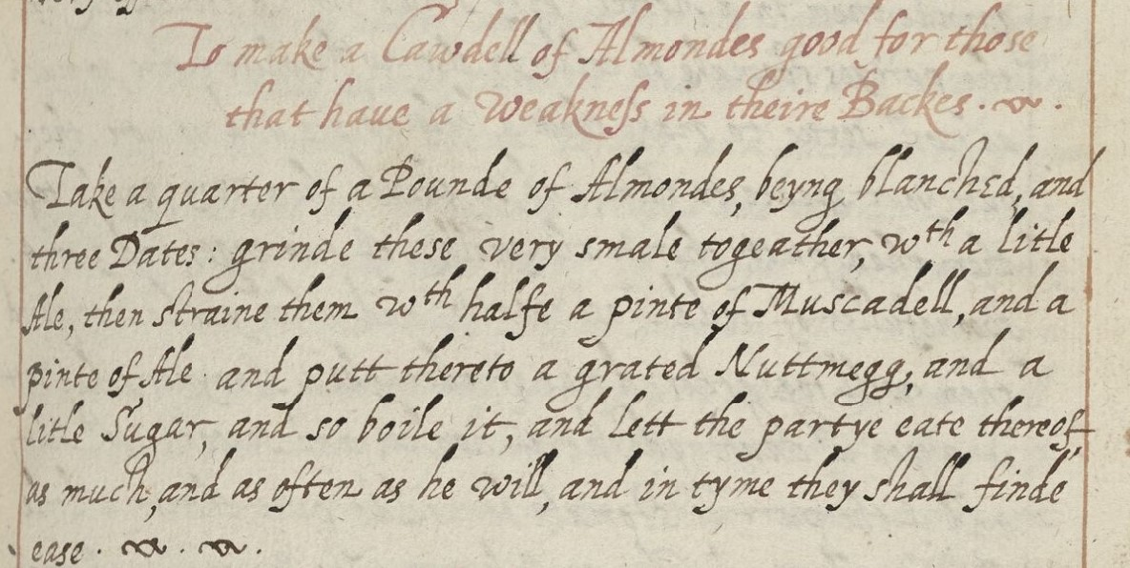

To make a Cawdell of Almondes good for those

That haue a weakneſs in theire Backes. flourish.

Take a quarter of a Pounde of Almondes, being blanched, and

three dates: grinde these very smale togeather, w*i*th a little

Ale, then straine them w*i*th halfe a pinte of Muscadell, and a

pinte of Ale and putt thereto a grated Nuttmegg, and a

little Sugar, and so boile it, and Lette the partye eate thereof,

as much, and as often as he will, and in tyme they shall finde

ease. flourish. flourish.

Definitions:

Cawdell: caudel, a strong drink for sick people, similar to a posset but without milk (Merriam-Webster)

Muscadell: a type of wine grape, likely here referring to the wine made thereof (Collins Dictionary)

Purpose of the Recipe: Here, you will give a “modern translation” of what the title claims the recipe is for (i.e., if it says something like “a drinke to cleare the sight” you can say that this recipe is intended to help with blurry vision, or something like that).

Ingredients:

Almonds

Dates

Ale

Nutmeg

Sugar

Process:

Take ¼ of a pound of sun-lightened almonds, grind it finely with three dates and a little ale. Then add a grated nutmeg and a pinch of sugar, and boil the mixture. Eat as much as often as you like, you will find relief eventually.

Observations:

I am intrigued by their use of “party” to refer to a person here. It is the first time I have encountered the word in this assignment, and I am generally used to seeing it used to define one group/person in contrast to another, as opposed to simply using it to refer to a singular person here.

I cannot see how this caudel would relieve back pain, unless the sweetness of it is meant to distract from the pain. I am especially left unconvinced by the extreme liberality of choice for when and how to administer it.